# Kickstarter Analysis

This document is meant to provide a commentary to the Kickstarter dataset contained in the Starter Book excel file, organized by responses to 3 questions.

## What are three conclusions we can make about Kickstarter campaigns given the provided data?

Comments below provide insights on type, timing and goal levels of Kickstarter campaigns in hopes of providing insight to those who wish to learn from past campaigns.

### Types of Campaigns – Kickstarter Campaigns for the Arts boast highest counts and success rates

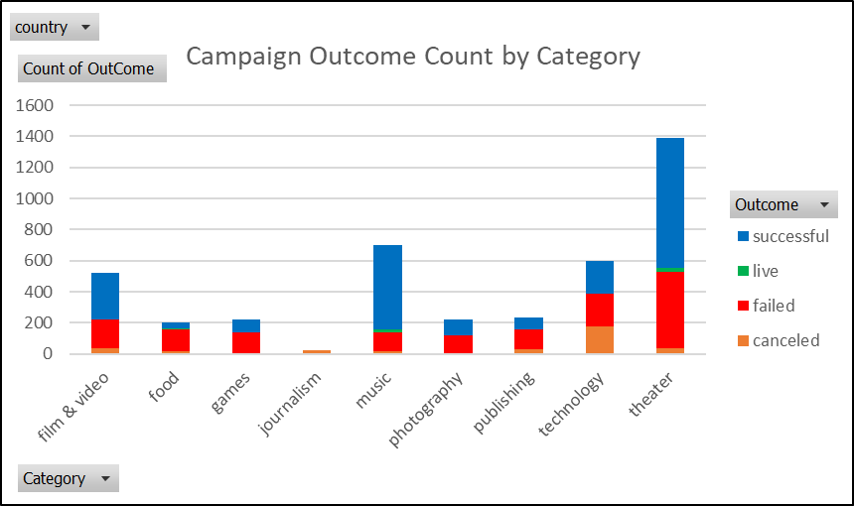

Globally, the most numerous campaigns are theater, followed by music and technology. Most of theater campaigns are for plays, which are successful more than 50% of the time. Music campaigns for rock, metal, classical, electronic are almost always successful, whereas jazz and faith are more often canceled or failed. Technology campaigns are successful only about 30% of the time, however those specifically categorized as hardware are successful almost all the time.

### Seasonality of Campaigns – Campaigns Beginning in May have the most successful outcomes

May appears to be the sweet spot for starting a Kickstarter campaign. Of completed campaigns the number of successful campaigns is about half of the combined total of failed and canceled campaigns.

Since its beginning in 2009, 2015 has the highest number of campaigns showing an increase of 8700% since 2009, and 2017 is showing to be the lowest year since 2010 at only 110% increase. Campaign managers may be interested in why Kickstarter campaigns numbered so low in 2017 to ensure they are using the most effective and updated tools to raise funds.

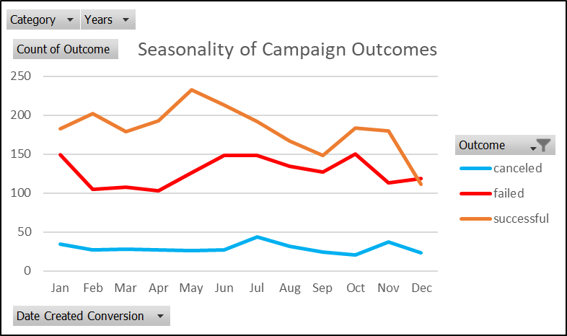

### Goals Levels of Campaigns – Campaigns with Goal Levels >$45,000 show a decrease in successful outcomes

Campaigns with a goal under $10,000 have success rates greater than 50%. Interestingly, success rates remain consistent for campaigns with goals ranging from $10,000 to $45,000. However, after $45,000 success rates drop off drastically.

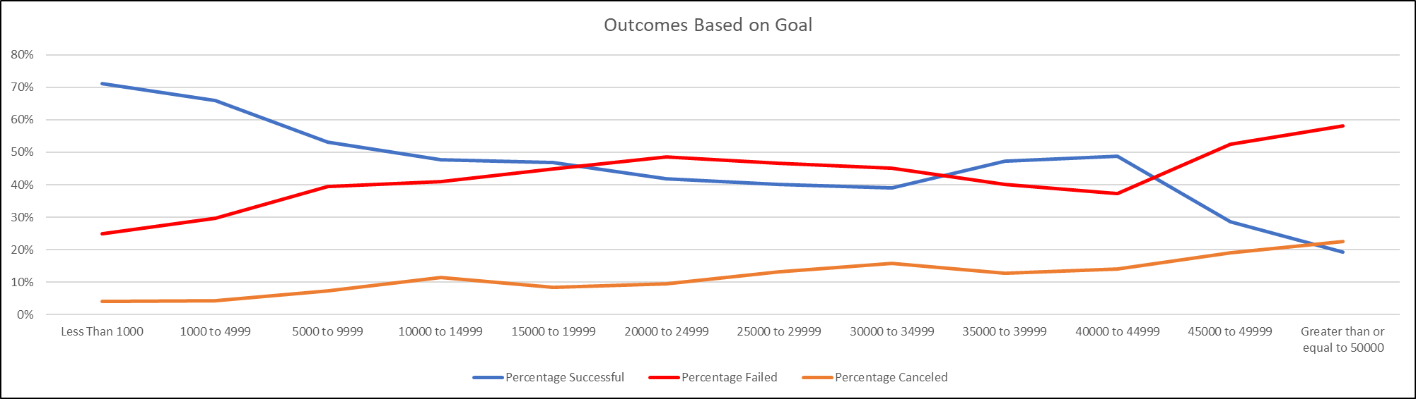

This indicates that the fundraising goal alone cannot determine the likelihood of successful outcome.

## What are some of the limitations of this dataset?

If people are looking for campaign success factors, this dataset does not contain all necessary information. Campaign managers might be interested in looking at additional data points such as:

* Donation Amount by Donor: Is there a typical donor distribution that indicates a successful outcome?
* Demographics of People Managing the Campaigns: Does the skillset, personality, gender, age or geography correlate to success?
* Marketing Strategies: Are specific methods like Facebook campaigns, personal and mass emails or phone calls linked to a better outcome?

It is also difficult to measure how campaigns resonate with potential donors. This is something that is hard to measure, but could be useful in evaluating effectiveness of a Kickstarter campaign vs. another fundraising method for an individual campaign.

## What are some other possible tables/graphs that we could create?

Of the dataset provided, there are additional graphs that could provide valuable insights:

* Outcome vs. Time between launch and deadline: to discover if the amount of time for raising funds has any correlation with success
* Outcome vs. Staff picks: to see if the staff’s preferences/picks had any correlation with success (either because of their SME knowledge or their support for the project)
* Number of Backers, Average Donation vs Outcome